Quality of Life Estimation with Structural Equation Modeling in School Aged Children with Asthma

Sheniz Moonie, Xuan Huang, David A. Sterling

Significant increases in childhood asthma prevalence and mortality has prompted federal and regulatory agencies to work towards a national framework to address childhood asthma. Quality of life is an important component of chronic disease, and the evaluation of healthcare outcomes. There is little discussion in the literature regarding the implications of QoL as a theoretical construct. This study determined the effect of asthma on the QoL of our study population and caregiver’s missed workdays on the child’s QoL scores. A negative relationship was found between the child’s QoL and the caregiver’s missed workdays due to their child’s asthma. The use of SEM and multiple group analysis can help increase awareness and understanding among the complex issues related to childhood asthma and quality of life constructs.

Background

Asthma is the most common chronic disease of childhood, the leading cause of absences from schools, and exerts a substantial influence in affected children’s lives and the lives of their primary caregivers. According to the 2005 National Health Interview Survey, there are nearly 6.5 million children with asthma in the United States. Approximately 6.7 percent of Missouri adults live in households with at least one child with asthma.

African-Americans and young children have a higher prevalence of asthma than Whites or other racial groups. Among males, the asthma hospitalization rate for African-Americans is greater than the rate for Whites across all age groups in the state. The largest asthma burden is evident in the 15 year old and younger age group.
Asthma is a critical global health issue affecting millions of adults and children in all countries and has received considerable attention federally since 1997. In recognition of the growing body of scientific information for this growing epidemic, president Clinton issued Executive Order 13045 on April 21st, 1997, directing each Federal Agency to make it a high priority to identify, assess, and address the area of asthma. Upon issuing this order, the President also created the Task Force on Environmental Health Risks and Safety Risks to Children, co-chaired by Donna Shalala, Secretary of the Department of Health and Human Services (DHHS) and Carol M. Browner, Administrator of the Environmental Protection Agency (EPA). Two subcommittees were established in this Executive order: a subcommittee directed to review and foster public access to Federal Government sponsored research on environmental health and safety risks to children, and a subcommittee directed to identify public outreach activities related to protecting children’s environmental health and safety. In April of 1998, the Task Force identified childhood asthma as one of four priority areas for immediate attention along with unintentional injuries, developmental disorders, and childhood cancer. The Task Force then created the Asthma Priority Area Workgroup, co-chaired by Ms. Shalala and Browner to make appropriate recommendations for action by the Federal Government. The first goal was to assess the risk factors associated with the onset of asthma and the triggers of asthma attacks. The efforts of this task force focused on four recommendations presented by the Federal Government for addressing childhood asthma: (1) a focus on efforts to eliminate the disproportionate impact of asthma in minority populations and those living in poverty, (2) an emphasis on partnerships and community based programs, (3) a commitment to setting consistent and measurable goals for childhood asthma under the Healthy People 2010 program and (4) an investment in evaluation to identify those strategies that are most effective in reducing the burden of asthma so they may be later replicated. It is critical to be able to measure the quality of life among children with asthma to determine how much progress we are making in line with these federally mandated initiatives.
The Children’s Health Act was issued in 2000 in order to expand research, prevention, and treatment efforts targeted at childhood illnesses, and a section entitled “Asthma Services for Children” specifically focuses on childhood asthma. Under this act the National Asthma Education and Prevention Panel was designated two main tasks: providing an annual report to Congress on all federal asthma activities, and developing, in consultation with appropriate federal agencies and other health organizations, recommendations to Congress for improving asthma-related federal activities. The main agendas are as follows: (1) to provide comprehensive asthma services to children to improve overall quality of life, (2) to equip mobile health care clinics, and (3) to conduct patient and family education on asthma. This paper will focus on data supporting the first federal agenda.
Quality Of Life (QoL) is usually considered in the terms of general health, physical functioning, physical symptoms and toxicity, emotional functioning, genitive functioning, role functioning, social well-being and functioning, and sexual functioning.

There is consensus on the need for monitoring outcomes of children with asthma in determining the best approach for management, and the use of QoL measures to assess management and outcomes. Three major categories of outcomes have been advocated: clinical and physiologic measurements, measurement of both generic and disease-specific health-related quality of life (HRQoL) and economic costs. Several studies have documented that HRQoL could provide a more comprehensive description of the impact of the illness in the lives of children with asthma. Numerous studies have estimated the relationship between QoL [or health related QoL (HRQoL)] and clinical and physiologic outcomes in pediatric asthma using several different childhood HRQoL instruments. Williams et. al. demonstrated a negative correlation between QoL and the number of missed schooldays among children with asthma. Other studies have documented that socio-demographic factors, such as age, gender, race, and household income, may have an association with HRQoL scores. However, there are no studies to our knowledge that estimate the relationship between QoL in children with asthma and the primary caregiver’s missed workdays due to their child’s asthma.
The Asthma 411 Initiative is an ongoing school-based implementation project working with school districts in and around the City of St. Louis, Missouri to improve asthma care and response to asthma. Within the project‘s activities, a comprehensive approach to assess and enhance education, including a QoL survey, was developed and implemented. Using these survey data, we tested which questions were the best indicators of QoL and whether differences existed between male and female children. We hypothesized a negative relationship between the child’s QoL and their caregiver’s missed workdays. Age, especially among school-aged children, is commonly considered as a confounder in social science and public health research, and therefore, we further assessed whether age confounded the relationship between the child’s QoL and the primary caregiver’s missed workdays.

Methods

Asthma Status Ascertainment

Students were identified as having asthma throughout the school year by the school nurse, previously described in one of the following ways: report by a parent/guardian to the nurse indicating the student has asthma; asthma medications (for example – albuterol) were supplied to the school nurse for administration or student self administration with a physician’s order; or a physician signed asthma action plan was submitted. Clinical evaluations for asthma including severity assessments were not performed. All students not meeting the above criteria were considered as not having asthma. Asthma case identification using school health records and school nurse evaluations has been shown to be an efficient method of tracking disease. However, asthma prevalence is likely to be underestimated as not all cases are necessarily reported administratively.

Study Sample

Consent letters and surveys were mailed home on April 2003 to all to students with asthma (N=874) enrolled in grades Kindergarten through 12 and a control group matched by grade in a predominantly African-American Missouri school district located in the greater Saint Louis Metropolitan region. To increase the participation rate, the first 30 students at the elementary and middle schools to return the surveys received a free movie rental card, and subsequent students who returned the survey received a gift basket. Surveys for children in grades K-3 were requested to be completed with the help of their primary caregiver and for those in grades 4-12, by the student, and requested to be returned to the school nurses within 30 days. A two month period was allotted to collect surveys prior to the end of the academic year.

Survey Instrument

The survey questions were adapted from a well-utilized instrument for childhood asthma – the Pediatric Asthma Quality of Life Questionnaire (PAQOL) developed by Juniper et al., which has been tested extensively for reliability and validity. The number of questions was reduced to account for the time limitations for completion. Questions related to the symptom and activity limitation domains were retained. The condensed survey included questions regarding how bothered in the past week students were by cough, wheeze, tightness of the chest and shortness of breath, and asthma attacks, limitation with physical activities, exposure to animals, and activities with friends and family. Response options for all of these questions were 7-point Likert scales ranging from ‘extremely bothered’ to ‘not bothered’. Additional information collected included caregiver missed days from work in the past 3 months due to the child’s asthma (5-point scale, from ‘0 days’ to ‘10 or more days’), annual household income (5- point scale, from ‘less than $15,000’ to ‘$60,001 or higher’), caregiver highest level of education (4- point scale, from ‘some high school’ to ‘graduate or other post college schooling’), and monthly cost of asthma medications and treatment (4- point scale, from ‘$0-$25’ to ‘more than $150’). The students’ demographic data, such as age, gender and race, were also obtained from the school district.
The main objectives of this survey were to determine: (1) the effect of asthma on the QoL of our study population; (2) whether socio-demographic factors influence the QoL among those with asthma; and (3) if there is a relationship between the caregiver’s missed workdays due to their child’s asthma and the child’s QoL scores. A control group was selected to confirm significant differences in respiratory conditions between those with and without asthma. This paper mainly focuses on the statistical QoL estimation method and the effect on the caregiver’s missed workdays among those with asthma. All components of this study were approved by the Saint Louis University Institutional Review Board.

Statistical Analysis

Structural equation modeling (SEM) was utilized in the present study. Through the use of SEM, researchers can assess complex models that evaluate the direct and indirect impact of several variables on one or more outcome variables. For the QoL scores, two different methods have been previously employed. The first method is the oblique rotation factor analysis since it was assumed (or verified) that the QoL items would be highly correlated. Another simple approach has been found in several studies in which mean scores for all items with related functions (symptom, activities limitation, emotion) are calculated. Subsequently, these scores are averaged to compile a total QoL score.
Since our survey questions were highly correlated, obtaining mean scores of all questions is a statistically invalid approach. The present study used the factor analysis approach as the first analytical step in obtaining the latent construct – QoL. Group analysis was then conducted to determine whether different factor loadings of QoL existed by gender.
For analyzing the relationship between socio-demographic factors, clinical symptomology, missed schooldays due to asthma, and QoL scores in previous studies, multiple linear regression analysis has been documented as a common technique. However, all variables in the regression model are assumed to be observable and to have no measurement error. Perfect measurement of instruments is seldom attained. Hence SEM analysis, which combines both measurement and path analysis, allows for assessment of indirect causal pathways to outcomes, and was applied as the second analytical step to assessing the relationship between the child’s QoL and the caregiver’s missed workdays in the present study. The number of caregiver’s missed work days was treated on a continuous scale for the purposes of the SEM model.
Statistical analysis was completed using LISREL (version 8.72; SSI Inc, 2005). The factor analyses were based on correlation structures. Multiple criteria of goodness-of-fit statistics were used in the assessment of model fit: (a) the Satorra-Bentler Scaled Statistic (S-B chi-square); (b) the Root Mean Square Error of Approximation (RMSEA); (c) the normed and non-normed fit indeces (NFI, NNFI); and the Comparative Fit Index (CFI). Values of RMSEA less than 0.05 indicate good fit, and values as high as 0.08 represent reasonable errors of approximation, values ranging from 0.08 to 0.10 indicate a mediocre fit, and those greater than 0.10 indicate a poor fit. Regarding NFI, NNFI and CFI, each provides a measure of complete co-variation in the data, with a value > 0.90 indicating an acceptable model fit.

Results

Two hundred and forty eight students (28.4 percent) with asthma returned survey forms. After data quality assurance procedures and missing data imputation (using the Prelis 2.50 methods for ordinal data), the effective sample size was reduced to 205 (82.7 percent). The mean age of the respondents was 14.6 years old (range 6-19 years). The majority of students were female (62.4 percent) and African-American (93.2 percent).
Figure 1 demonstrates the postulate that seven out of eight items load onto the latent construct - QoL. Four items are related to asthma symptoms: cough, wheeze, tightness in chest, and shortness of breath. Another item relates to asthma attacks, and two are related to activity limitation (Table 2): physical activities and activities with friends and family. Table 3 shows the results for the equivalency models. The difference between these two models exceeded the critical chi-square value (² = 19.83) associated with eight degrees of freedom and a 0.05 significance level. Hence, the measurement equivalence model was rejected, which demonstrated different factor loadings by gender. Therefore separate measurement models were used for subsequent analyses. The difference between males and females is shown in Table 4. Except for COUGH, the factor loadings for the other observed variables in boys are larger than those in girls. Therefore, two separate SEM models were created for assessing the relationship between the child’s QoL and their caregiver’s missed workdays. Figures 2 and 3 demonstrate these models for males and females, respectively. The model fit indices indicate well fitted models, since RMSEA is smaller than 0.10 and NFI, NNFI and CFI are all larger than 0.90. In these models, M_DAY is the new latent construct with a single indictor of missed workdays. Based on the Anderson recommendation of the estimate for error variance of the single indicator, the error variance of this observed variable was set to 0.10. The mean caregiver’s missed workdays due to the child’s asthma in the previous 3 months was 0.42 days (SD ± 0.67), and ranged from 0-2 days. A negative relationship between the child’s QoL and the caregiver’s missed workdays was determined in both models. The coefficients in the path analysis were –0.51 for males and –0.48 for females.
When assessing whether the child’s age was a confounder of this negative relationship, another new latent construct S_AGE with a single indictor of age was added. It is typically considered that there is minimal error for the reporting of age. Hence, the error variance of this variable was set to zero. Figures 4 and 5 show the final SEM models in both subgroups. The model fit indices demonstrate a good fit for these two models. For both models, age did not change the direction of the relationship between the child’s QoL and missed workdays. However, upon comparing coefficient changes, age affected the relationship in the male subgroup (reduction from 0.51 to 0.40), yet did not change for the female subgroup. The coefficients between S_AGE and M_DAY and S_AGE and QoL were very small (-0.04 and –0.06, respectively) in the female subgroup. However, larger coefficients were found in the male subgroup. In addition, age showed an inverse relationship with missed workdays, but a positive relationship with QoL.

Discussion

The measurement model applied in this study one was of the first that attempted to estimate QoL among children with asthma. Seven items, reflecting two domains (symptom and activity limitation) from Juniper’s original survey, were responsive to the QoL scores. However, this QoL score demonstrated different patterns among the gender subgroups. According to the 2006 CDC’s nationwide asthma report, males experience a higher current asthma prevalence rate and death rate throughout most of childhood compared with females. The male subgroup in our study had a higher response rate than the female subgroup. Since a greater disease burden contributes to a lower QoL, this is a possible explanation for the higher factor loadings of QoL in the male group compared with the female group.
The hypothesized negative relationship between the child’s QoL and the caregiver’s missed workdays due to the child’s asthma was verified. The lower the QoL score, the worse the symptoms and activity limitations, reflecting more missed workdays
. In addition, we found that older age of the child was associated with less caregiver’s missed workdays. This is logical as older children should have more disease knowledge and better control abilities than those of younger ages. In the male subgroup, increasing age was also associated with higher QoL scores. A possible explanation is that older kids have better control with their disease, more knowledge, and stronger self-management skills. In addition, the caregivers of older symptomatic children are more likely to feel comfortable leaving them at home while attending their regular work schedule.
Age was considered a confounder of the relationship between the child’s QoL and the caregiver’s missed workday among boys, but this relationship did not exist among the female subgroup. There are two possible explanations for this apparent difference. The sample size differences may have been a contributor. There were more female respondents (n = 128) than males (n = 77). A sample size of more than 200 is optimal when using the SEM approach. Secondly, the distribution of age within the subgroups was different. The average age for the female subgroup was older than the male subgroup by a few years. Seventy seven percent of the students are between 15 to 18 years in the female subgroup, yet only 52 percent are within this range for the male subgroup. The male subgroup demonstrated a more normal distribution of age than the female subgroup. While the male subgroup showed more variability of age, the female group showed more consistency. Therefore, these two models reflected a different influence of age.
The study had several limitations. First of all, the findings lack external validity as the data come from one school district and one state. Therefore we will not be able to generalize these findings to other states or the nation. Secondly, asthma prevalence was likely to be underestimated as not all cases are reported through the school health form or school nurse evaluation. Therefore, it is possible that some asthma cases ended up in the non-asthma group, diluting findings differentially towards the null. Missing data that could not be imputed reduced our sample size from 248 to 205 subjects. Some key variables could not be evaluated if missing values compromised more than 70 percent of the response. Some of these potentially influential variables included household annual income, caregiver’s highest education level, and extra financial burden. It is possible that these questions were too sensitive for the respondents to answer. Additionally, we did not include questions regarding emotional function, which are included in the original Juniper survey. Follow-up studies conducting in person interviews with the complete survey and a larger sample size are recommended to confirm the associations that were found.
Many patients show fluctuations in asthma severity throughout the year, and neither asthma control, nor severity information on these respondents was available. Asthma severity and control directly parallel quality of life issues, and it is likely that the time period captured, was not representative of the caregiver’s absenteeism during the entire study period. Therefore, we most likely report an underestimate of the effect of asthma on the QoL of our study population.

Conclusions

The importance of the application of SEM and multiple group analysis in evaluating QoL is demonstrated in this analysis, and verified the negative relationship between the child’s QoL and parental missed workdays. Follow-up studies are recommended to further assess the effect of asthma severity and control issues on the QoL of children with asthma. We hope that our findings can help to begin increasing the awareness and understanding surrounding the complex issues related to childhood asthma and quality of life.

Sheniz Moonie is an Assistant Professor in the Division of Biostatistics and Epidemology at the University of Nevada, Las Vegas, School of Public Health. She is a statistician with expertise in clinical programming and pediatric asthma research.

Xuan Huang is a Statistical Data Analyst in Division of Biostatistics, Washington University in St. Louis. She received her Master’s Degree of Public Health with a concentration in Biostatistics from Saint Louis University School of Public Health in 2005.
David A. Sterling is Professor and Chair, Department of Environmental and Occupational Health, School of Public Health at the University of North Texas Health Science Center in Fort Worth. His specialty areas are in exposure and risk assessment methodologies and exposure linkages with health outcomes.
Figure 1: Measurement Model of QOL for all Students

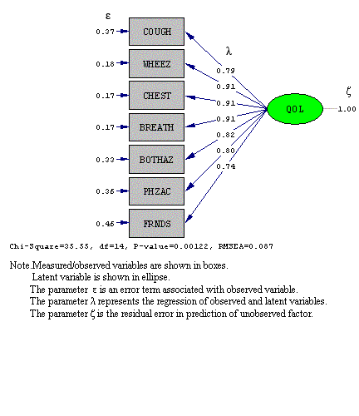

Figure 2: Structural Equation Model of Negative Relationship between QOL and Missed Workday in Male Subgroup
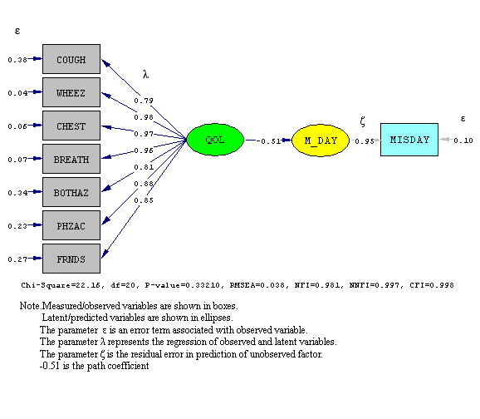

Figure 3: Structural Equation Model of Negative Relationship between QOL and Missed Workday in Female Subgroup

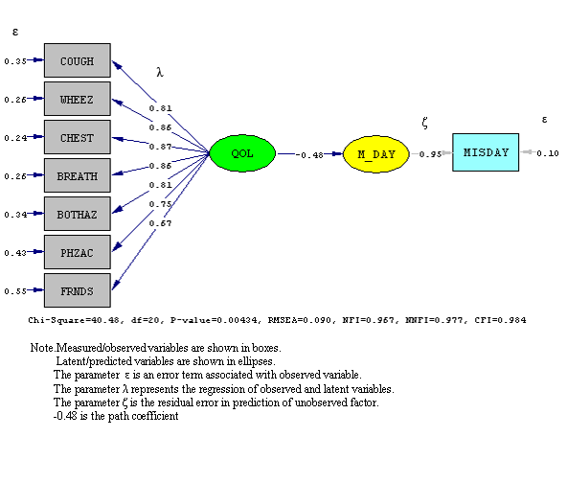

Figure 4: Structural Equation Model of Relationship among QOL, Caregiver Missed Workday and Student Age in Male Subgroup

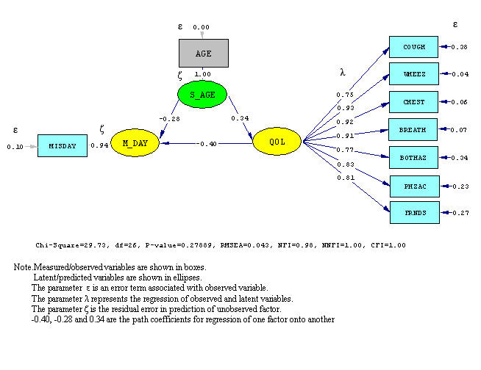

Figure 5: Structural Equation Model of Relationship among QOL, Caregiver Missed Workday and Student Age in Female Subgroup

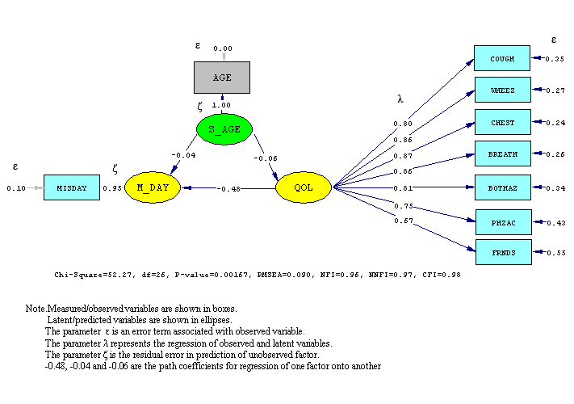

Table 1. Population Demographics
Sample Size* | n = 205 (82.7%)
Mean age of child (years) | 14.6 [6,19]
Male | 77 (37.6%)
Female | 128 (62.4%)
Race
African American | 191 (93.2%)
White | 14 (6.8%)
* refers to those who completed the survey that qualified

Table 2. Estimators of QoL for Students with Asthma (n=205)
Item | Content | Factor
COUGH | How bothered has your child been during the last week by coughing? | 0.79
WHEEZ | How bothered has your child been during the last week by wheezing? | 0.91
CHEST | How bothered has your child been during the last week by tightness in his/her chest? | 0.91
BREATH | How bothered has your child been during the last week by shortness of breath? | 0.91
BOTHAZ | How bothered has your child been during the last week by asthma attacks? | 0.82
PHZAC | How bothered has your child been during the last week doing physical activities? | 0.80
FRNDS | How bothered has your child been during the last week doing activities with friends and family? | 0.74

Table 3. Equivalency Models
Model | S-B Chi-square  (df) | Model differences
Completely unequivalent | 38.17 (28) | N/A
Measurement equivalence | 58.00 (36) | 19.83 (8)
Note. df = degree of freedom. p = 0.011

Table 4.
Factor Loadings of QoL: Male and Female Subgroups
Item | Group
Item | Male  (n = 77) | Female  (n = 128)
COUGH | 0.79 | 0.80
WHEEZ | 0.98 | 0.86
CHEST | 0.97 | 0.88
BREATH | 0.96 | 0.86
BOTHAZ | 0.81 | 0.81
PHZAC | 0.87 | 0.75
FRNDS | 0.85 | 0.67

L.J. Akinbami, “The State of Childhood Asthma, United States, 1980-2005,” Vital and Health Statistics 381, (2006): 1-24; S.A. Moonie, D.A. Sterling, L.W. Figgs, and M. Castro, “Asthma Status and Severity Affects Missed Days From School,” Journal of School Health 76, no.1 (2006): 18-24; H. Taras and W. Potts-Datema, “Childhood Asthma and Student Performance at School,” Journal of School Health, 75, no.8 (2005): 296-312.
Centers for Disease Control and Prevention, National Health Interview Survey: Summary Health Statistics for the United States 2005 [cited April 18th, 2007, from http://www.cdc.gov/nchs/nhis.html.
J.E. Miller, “The Effects of Race/Ethnicity and Income on Early Childhood Asthma Prevalence and Health Care Use,” American Journal of Public Health 90, no.3 (2000): 428-430.
U.A. Rana, S.M. Jurgens, S Mangione, J Elia, and D.J. Tollerud, “Asthma Prevalence Among High Absentees of Two Philadelphia Middle Schools,” Chest 118, no.4 (2000): 79S; Missouri Department of Health and Senior Services, “ASTHMA in Missouri,” edited by S. o. C. D. P. a. H. Promotion, (2002).
Global Strategy for Asthma Management and Prevention. GINA Report 2007 [cited May, 2008 from http://www.ginasthma.org.
United States Environmental Protective Agency, President's Task Force on Environmental Health and Safety Risks to Children: Asthma and the Environment - A Strategy to Protect Children, n.d. [cited January, 2000 from http://www.epa.gov.html.
National Heart Lung and Blood Institute, Setting the Action Agenda to Achieve National Asthma Objectives n.d. (cited October 22, 2002 from http://www.nhlbi.nih.gov/health/prof/lung/asthma/am_sp01/setadj.html).
P.M. Fayers and D. Machin, Quality of Life Assessment, Analysis, and Interpretation, (Original edition, Willey Publication, 2000).
M. S. Blaiss, “Measuring outcomes in pediatric asthma”. Allergy & Asthma Proceedings 22, no.2 (2001): 63-5.
J.W. Varni, T.M. Burwinkle, M. Seid, and D. Skarr, “The PedsQL 4.0 as a Pediatric Population Health Measure: Feasibility, Reliability, and Validity,” Ambulatory Pediatrics 3, no.6 (2003):329-341; J.W. Varni, M. Seid, T. S. Knight, K. Uzark, and I. S. Szer, “The PedsQL 4.0 Generic Core. Scales: sensitivity, responsiveness, and impact on clinical decision-making,” Journal of Behavioral Medicine 25, no.2 (2002):175-93.
R.D. Annett, B. G. Bender, T. R. DuHamel, and J. Lapidus, “Factors Influencing Parent Reports on Quality of Life for Children with Asthmas,” Journal of Asthma 40, no.5 (2003):577-587; G.H. Guyatt, E. F. Juniper, L. E. Griffith, D. H. Feeny, and P. J. Ferrie, “Children and Adult Perceptions of Childhood Asthma,” Pediatrics 99, no.2 (1997): 165-168; A. Somerville, B. Knopfli, and C. Rutishauser, “Health-related Quality of Life in Swiss Adolescents with Asthma.Validation of the AAQOL-D and Comparison with Australian adolescents,” Swiss Medical Weekly 134, no. 7-8 (2004): 91-96. G. Vila, R. Hayder, C. Bertrand, B. Falissard, J. De Blic, M. C. Mouren-Simeoni, and P. Scheinmann, “Psychopathology and Quality of Life for Adolescents with Asthma and Their Parents,” Psychosomatics 44, no. 4 (2003): 319-328; S. Williams, M. Sehgal, K. Falter, R. Dennis, D. Jones, J. Boudreaux, D. Homa, C. Raskin-Hood, C. Brown, M. Griffith, and S. Redd, “Effect of Asthma on the Quality of Life Among Children and Their Caregivers in the Atlanta Empowerment Zone,” Journal of Urban Health 77, no.2 (2000): 268-79.
S. Williams, M. Sehgal, K. Falter, R. Dennis, D. Jones, J. Boudreaux, D. Homa, C. Raskin-Hood, C. Brown, M. Griffith, and S. Redd, “Effect of Asthma on the Quality of Life Among Children and Their Caregivers in the Atlanta Empowerment Zone,” Journal of Urban Health 77, no.2 (2000):268-79.
R. D. Annett, B. G. Bender, J. Lapidus, T. R. Duhamel, and A. Lincoln, “Predicting Children’s Quality of Life in an Asthma Clinical Trial: What Do Children’s Reports Tell Us?”Journal of Pediatrics 139, no.6 (2001): 854-861; S.R. Erickson, P. J. Munzenberger, M. J. Plante, D. M. Kirking, M. E. Hurwitz, and R. Z. Vanuya, “Influence of Sociodemographics on the Health-Related Quality of Life of pediatric Patients with Asthma and Their Caregivers,” Journal of Asthma 39, no.2 (2002): 107-17; Guyatt, G. H., E. F. Juniper, L. E. Griffith, D. H. Feeny, and P. J. Ferrie, Children and adult perceptions of childhood asthma. Pediatrics 99, no. 2 (1997):165-8.
C. Richmond, D.A. Sterling, X. Xuang K. Wilson, and E. Pike, “Asthma 411- A School Initiative,” Journal of School Health (2006).
S.A. Moonie, D.A. Sterling, L.W. Figgs, and M. Castro, “Asthma Status and Severity Affects Missed Days From School,” Journal of School Health 76, no.1 (2006): 18-24.
A.T. Hilton, P.T. Millard, and M. Johnson, Finding School-age Children with Asthma, paper read at American Thoracic Society, at Orlando, Florida (2004); R.S. Knorr, S.K. Condon, F.M. Dwyer, and D.F. Hoffman, “Tracking pediatric asthma: the Massachusetts experience using school health records,” Environmental Health Perspectives 112, no.14 (2004):1424-27.
Missouri Department of Elementary and Secondary Education. n.d. [cited March, 2005, from http://www.dese.mo.us.html.
E.F. Juniper, G.H. Guyatt, D.H. Feeny, P.J. Ferrie, L.E. Griffith, and M. Townsend, “Meausuring Quality of Life in Children with Asthma,” Quality of Life Research 5, no.1 (1996): 35-46.
C.M. Musil, S. L. Jones, and C. D. Warner, “Structural Equation Modeling and its Relationship to Multiple Regression and Factor Analysis,” Research in Nursing & Health 21, no. 3 (1998):271-281.
R. D. Annett, B. G. Bender, J. Lapidus, T. R. Duhamel, and A. Lincoln, “Predicting Children’s Quality of Life in an Asthma Clinical Trial: What Do Children’s Reports Tell Us?”Journal of Pediatrics 139, no.6 (2001):854-861; E.F. Juniper, M. E. Wisniewski, F. M. Cox, A. H. Emmett, K. E. Nielsen, and P. M. O'Byrne, “Relationship Between Quality of Life and Clinical Status in Asthma: A Factor Analysis,” European Respiratory Journal 23, no.2 (2004): 287-91; G. Vila, R. Hayder, C. Bertrand, B. Falissard, J. De Blic, M. C. Mouren-Simeoni, and P. Scheinmann, “Psychopathology and Quality of Life for Adolescents with Asthma and Their Parents,” Psychosomatics 44, no.4 (2003): 319-328.
R.D. Annett, B. G. Bender, T. R. DuHamel, and J. Lapidus, “Factors Influencing Parent Reports on Quality of Life for Children with Asthmas,” Journal of Asthma 40, no.5 (2003): 577-587; S.R. Erickson, P. J. Munzenberger, M. J. Plante, D. M. Kirking, M. E. Hurwitz, and R. Z. Vanuya, “Influence of Sociodemographics on the Health-related Quality of Life of Pediatric Patients with Asthma and Their Caregivers,” Journal of Asthma 39, no. 2 (2002): 107-117; G.H. Guyatt, E. F. Juniper, L. E. Griffith, D. H. Feeny, and P. J. Ferrie, “Children and Adult Perceptions of Childhood Asthma,” Pediatrics 99, no.2 (1997): 165-168
J.C. Anderson, and D.W. Gerbing, “Structural Equation Modeling in Practice: A Review and Recommended Two-step Approach,” Psychological Bulletin 103, no. 3 (1988): 411-423.
L.J. Akinbami, “The State of Childhood Asthma, United States, 1980-2005,” Vital and Health Statistics 381 (2006): 1-24.
E.F. Juniper, G.H. Guyatt, D.H. Feeny, P.J. Ferrie, L.E. Griffith, and M. Townsend, “Meausuring Quality of Life in Children with Asthma,” Quality of Life Research 5, no.1 (1996): 35-46.

